Overview

Business Process Procedure Overview
For GSD customers having rate categories GSD_1120 and GSD_1130, the following changes may occur:

- For customers being billed with power factor whose meter have been replaced with an AMI meter, the power factor will no longer be read. The power factor will be calculated using the KWH and KVARH index reads and stored in the installation fact PWERFACTOR.

- For customers being billed with the default power factor of 0.85 whose meter have been replaced with an AMI meter, the actual power factor will be calculated using the KWH and KVARH index reads and stored in the installation fact PWERFTCALC. They will still be billed the default power factor which is stored in installation fact PWERFACTOR.

Note: The max demand installation fact was not changed. The billed max demand is still stored in KW_BILLED.

For GS customers having rate categories GS_1100 and GS_1110 who has participated on rate analysis, the following change are applicable:

- For customers whose meter have been replaced with an AMI meter, the actual power factor will be calculated using the KWH and KVARH index reads and stored in the installation fact PWERFTCALC. This is only used for analytical purpose, and is not used in billing.

- Demand being calculated over the air will be stored in a new installation fact KW_MX_DEMR. This is only used for analytical purpose, and is not used in billing.

Procedural Steps

- Viewing installation facts for applicable GSD Customers

Display the installation

(Transaction Code can be displayed by selecting System -> Status)
ES32

Enter the installation number and hit Enter.

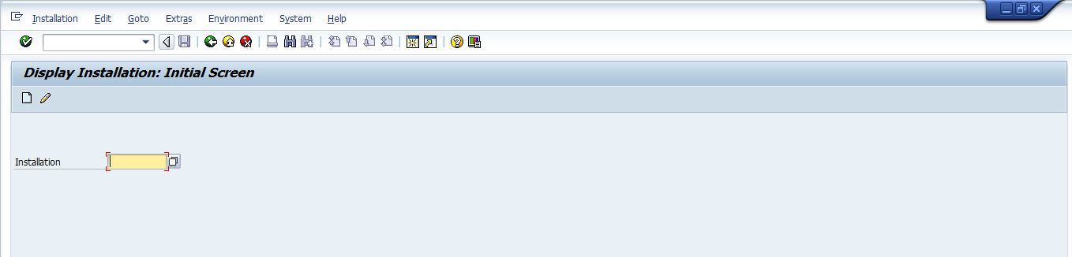

Display the installation facts screen

Click on the Facts button to display the installation facts

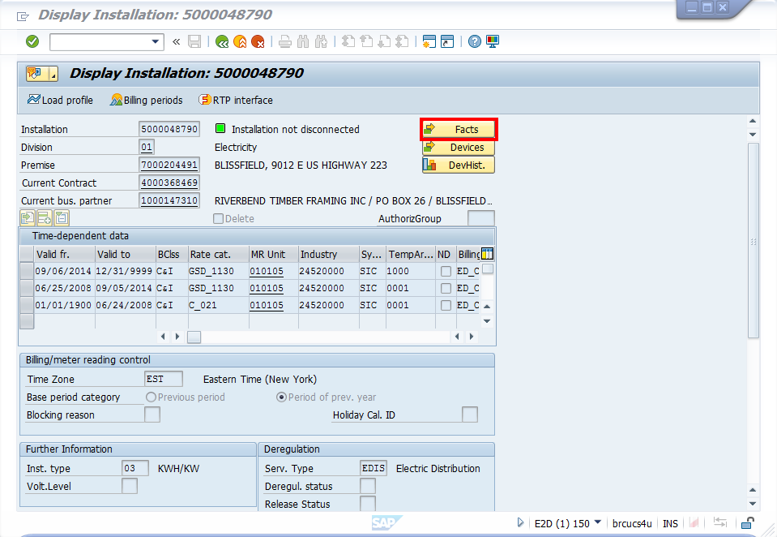

View the installation facts for power factor

Expand the RUN TIME node
The power factor billed can be found in operand PWERFACTOR.

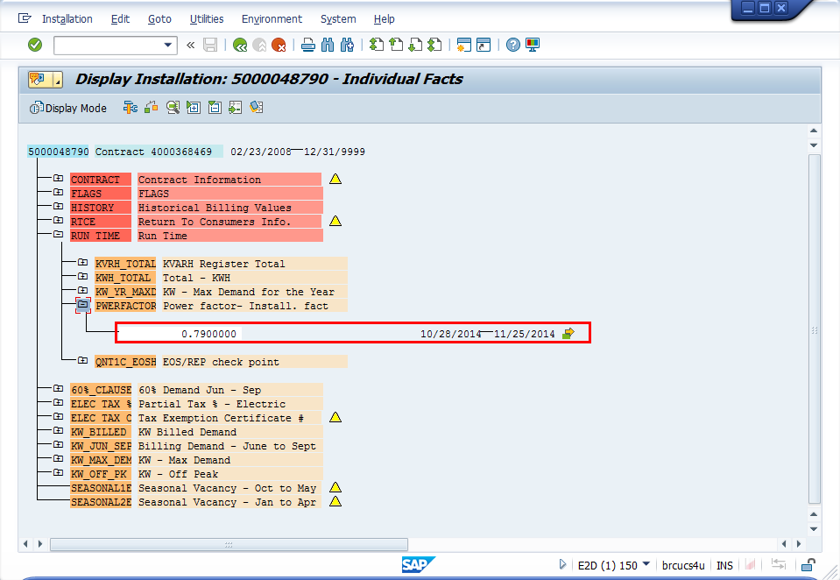

For customer being billed with the default power factor, the default power factor billed can be found in operand PWERFACTOR and the calculated power factor can be found in operand PWERFTCALC.

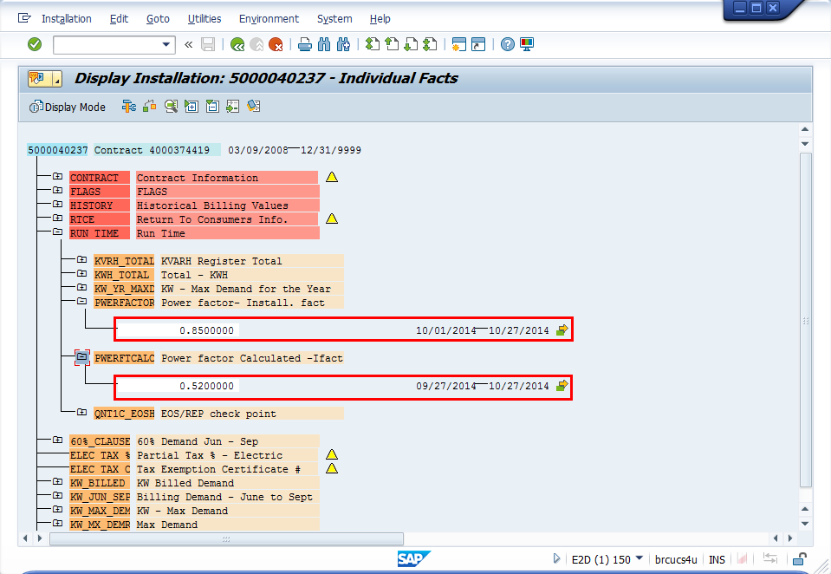

View the installation facts for demand

The max demand billed can still be found in operand KW_BILLED.

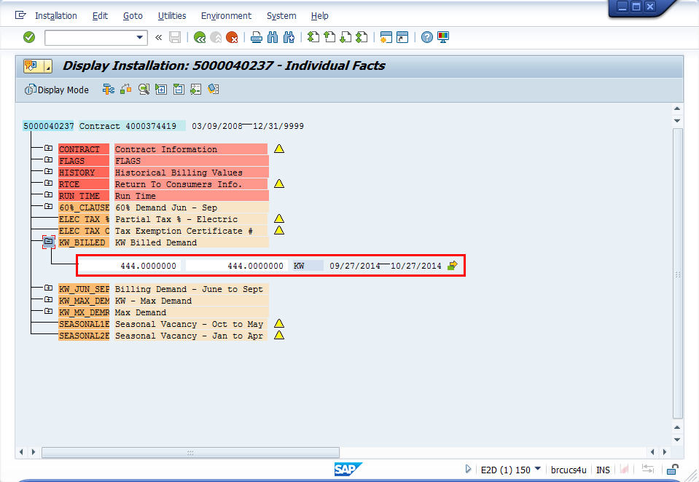

- Viewing installation facts for applicable GS Customers

Display the installation
(Transaction Code can be displayed by selecting System -> Status)
ES32

Enter the installation number and hit Enter.



Display the installation facts screen

Click on the Facts button to display the installation facts

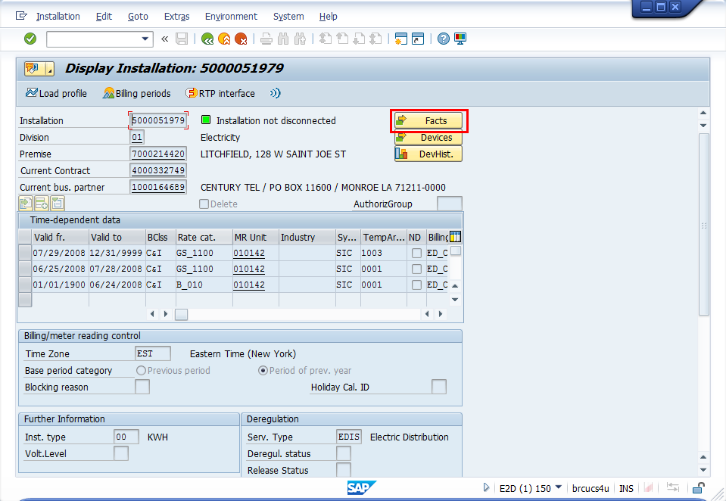

View the installation facts for power factor

Expand the RUN TIME node
The power factor billed can be found in operand PWERFTCALC.

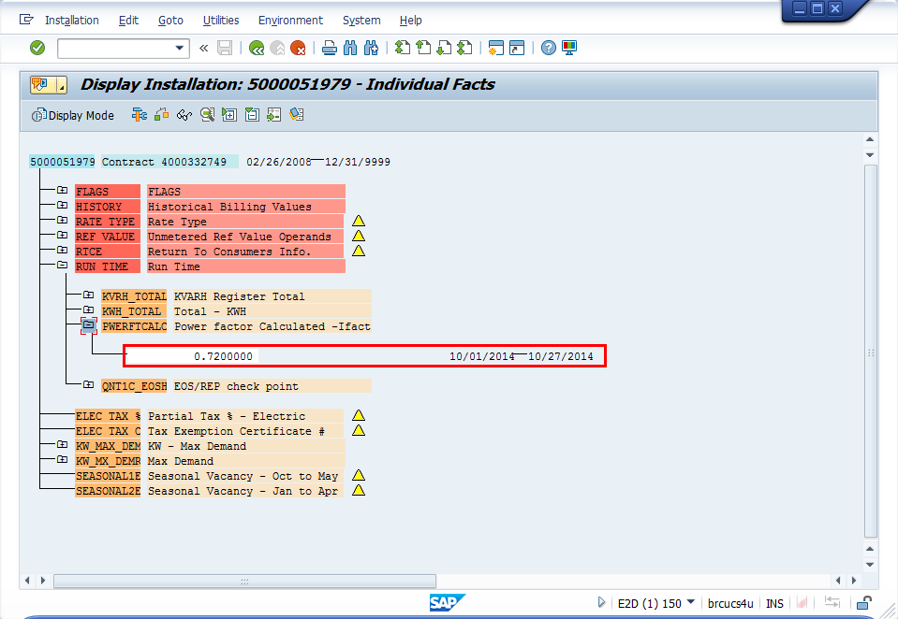

View the installation facts for demand

The max demand calculated over the air can be found in installation fact KW_MX_DEMR.

